Replace all the red text in this document before submission.
Solent University

School: Department of Science and Engineering
Course: Cyber Security
Module: Introduction to Databases (COM430)
Assessment: AE1 Portfolio

Student: 103048653
(Do not enter your name if you wish your submission to be anonymously marked)
Date: 18/03/2025

Contents Page
Retrieving Data using SQL: 3
A) QUESTION: 3
SQL CODE: 3
EXPLANATION: 3
SCREENSHOT 4
TESTING 4
B) QUESTION: 5
SQL CODE: 5
EXPLANATION: 5
SCREENSHOT: 6
TESTING: 6

C) QUESTION: 7
SQL CODE: 7
EXPLANATION: 7
SCREENSHOT: 8
TESTING: 9
D) QUESTION: 10
SQL CODE: 10
EXPLANATION: 10
SCREENSHOT: 11
TESTING: 11

Retrieving Data using SQL:

A) QUESTION:

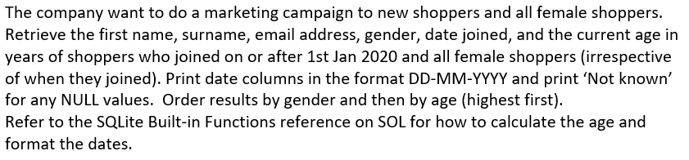

SQL CODE:

SELECT Shopper_first_name AS [Shopper First Name],

Shopper_surname AS [Shopper Surname],

Shopper_email_address AS [Email Address],

IFNULL(Gender, 'Not Known') AS [Gender],

STRFTIME('%d-%m-%Y', Date_Joined) AS [Date Joined],

CAST((JULIANDAY(DATETIME('now')) - JULIANDAY(Date_of_birth)) / 365.25 AS INTEGER) AS [Age]

FROM shoppers

WHERE Date_Joined >='2025-01-01' OR Gender = 'F'

ORDER BY Gender, Date_of_Birth DESC

EXPLANATION:
Lines 1-6 use the SELECT statement and select the shopper first name, surname, email address, gender, date joined and date of birth and use aliases to make the names more clear to read. Line 4 uses the ifnull keyword to change any null values to ‘Not Known’. Line 5 uses the STRFTIME function to show the date joined in a ‘day,month,year’ format instead of the default ‘year,month,day’ format. Line 7 uses the Cast function to convert the value of the date of birth into an integer. This is paired with the Julianday and datetime function to calculate the difference between the current date and the date of birth listed to produce the age and divide it by 365.25 to calculate the age. Line 8 shows the from statement to show where the data is selected from, this being shoppers. Line 9 shows the where statement to specify the condition to filter the results, which is the date joined being more than or equal to 1st January 2025 or the gender being equal to female. Line 10 shows the order by statement to show how the results should be ordered, which is by the gender and then the date of birth columns in a descending order.

SCREENSHOT:
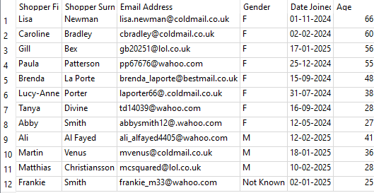
Date Ran: 26/02/2026

TESTING:
I sanity checked the boundaries of the query by selecting all shoppers who joined on or after 1st January 2025 and all the male shoppers in the first query appear in the check along with Gill

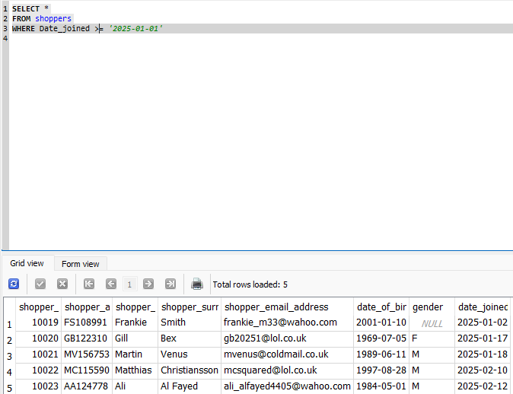

b) QUESTION:

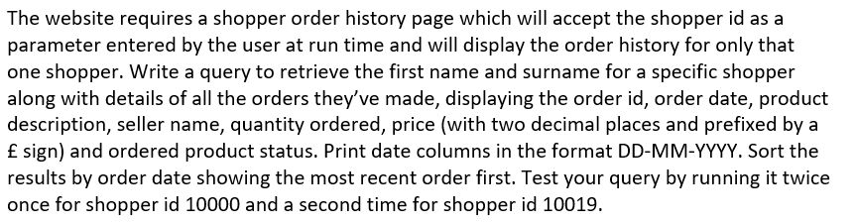

SQL CODE:

SELECT s.Shopper_first_name AS [Shopper First Name],

s.Shopper_surname AS [Shopper Surname],

so.Order_id AS [Order ID],

STRFTIME('%d-%m-%Y',so.Order_date) AS [Order Date],

p.Product_description AS [Product Description],

se.Seller_name AS [Seller Name],

op.Quantity AS [Quantity Ordered],

PRINTF("£%.2f",op.Price) AS [Price],

op.Ordered_product_status AS [Order Status]

FROM Shoppers s

INNER JOIN Shopper_orders so ON so.Shopper_id = s.shopper_id

INNER JOIN Ordered_products op ON so.Order_id = op.order_id

INNER JOIN Product_sellers ps ON op.Product_id = ps.product_id

AND op.Seller_id = ps.seller_id

INNER JOIN Sellers se ON ps.Seller_id = se.seller_id

INNER JOIN Products p ON ps.Product_id = p.product_id

WHERE s.Shopper_id =@ID

ORDER BY order_date DESC

EXPLANATION:
Lines 1-9 use the select statement to select the shopper first name, surname, order id, order date, product description, sellers name, quantity, price and product order status, with aliases to make the output names more clear. Line 4 uses the STRFTIME function to show the date joined in a ‘day,month,year’ format. Line 8 uses the PRINTF function to format the price with a pound sign and to 2 deciaml places. Line 10 uses the FROM statement to show the data is being taken from the shoppers table. Lines 11-16 show the use of inner joins to combine the results using their matching values, which are often the primary and foreign keys. Line 14 uses an AND condition as the ordered products and product sellers table have two matching rows, meaning both need to be joined. Line 17 uses the WHERE statement to show the condition, which is where the shopper id is a parameter used to filter the results. Line 18 uses the ORDER BY statement to show how the results should be shown, which is by order date, most recent first

SCREENSHOT:
10000: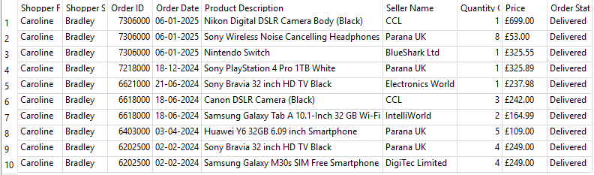

10019:

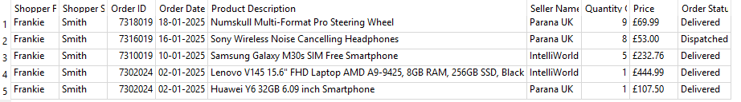

TESTING:
I tested the query by selecting all from shoppers where the first name is Caroline and it shows her shopper id is 1000 which matches up with the id in the original query

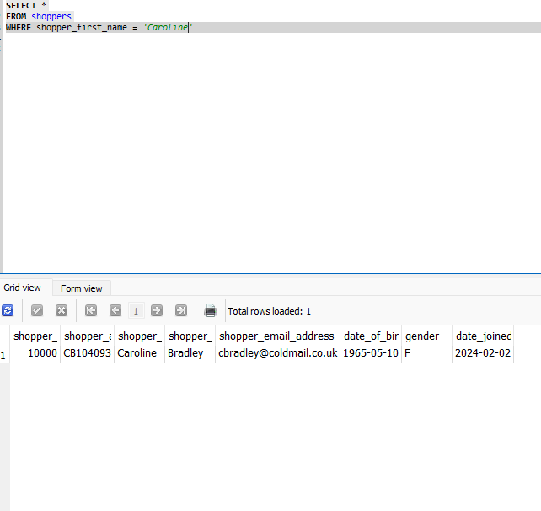

c) QUESTION:

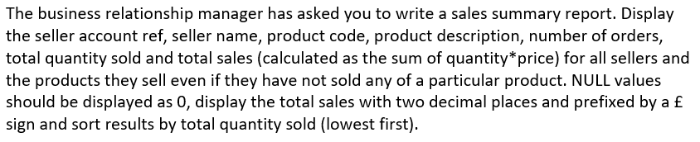

SQL CODE:

SELECT s.Seller_account_ref AS [Seller Account Ref],

s.Seller_name AS [Seller Name],

p.Product_code AS [Product Code],

p.Product_description AS [Product Description],

COUNT(op.Order_id) AS [No. of Orders],

SUM(IFNULL(op.Quantity, '0')) AS [Total Quantity Sold],

PRINTF('£%.2f',SUM(op.Quantity * op.Price)) AS [Total Value of Sales]

FROM Sellers s

INNER JOIN Product_sellers ps ON s.Seller_id = ps.seller_id

INNER JOIN Products p ON p.Product_id = ps.product_id

LEFT OUTER JOIN Ordered_products op ON ps.product_id = op.product_id

AND ps.seller_id = op.seller_id

GROUP BY s.Seller_account_ref, s.seller_name, p.product_code, p.product_description

ORDER BY [Total Quantity Sold] ASC

EXPLANATION:
Line 1-7 uses the SELECT statement to show the seller account reference, seller name, product code, product description, number of orders, total quantity sold and total value of sales, using aliases to make the names of the results more clear and easy to read. Line 5 uses the COUNT function to count and return all values within the order id column. Line 6 uses the SUM function to calculate the total sum of the values within the quantity column. Line 6 also uses the IFNULL keyword to change any null values within the column to 0. Line 7 uses the PRINTF function to format the price with a pound sign and to 2 decimal places. Line 7 also uses the sum function to calculate the output of quantity times by price. Line 8 uses the FROM statement to show where the data is being taken from. Lines 9-12 uses joins to combine the results using their matching values. Line 11 uses a left outer join instead of an inner join to return the results from the left table being product sellers and the matching results from the right table, being ordered products. Line 13 uses a group by function to group the seller account reference, seller name, product code and product description rows into summary rows where hey have the same values. Line 14 uses the order by function to show how the results should be ordered, which is by total quantity sold in an ascending order, meaning lowest first

SCREENSHOT:

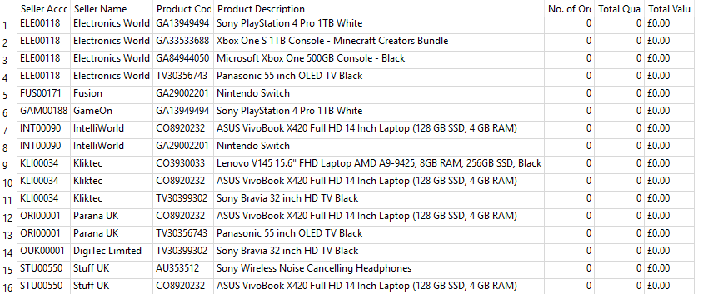

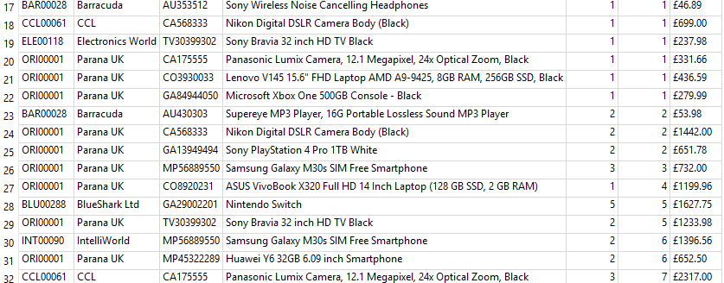

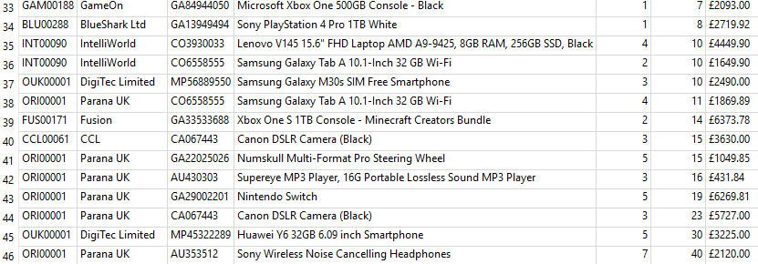

TESTING:
I selected all from my query where the number of orders and total quantity sold are 0 and the rows produced in the test match up with the rows in the original query where these values are 0
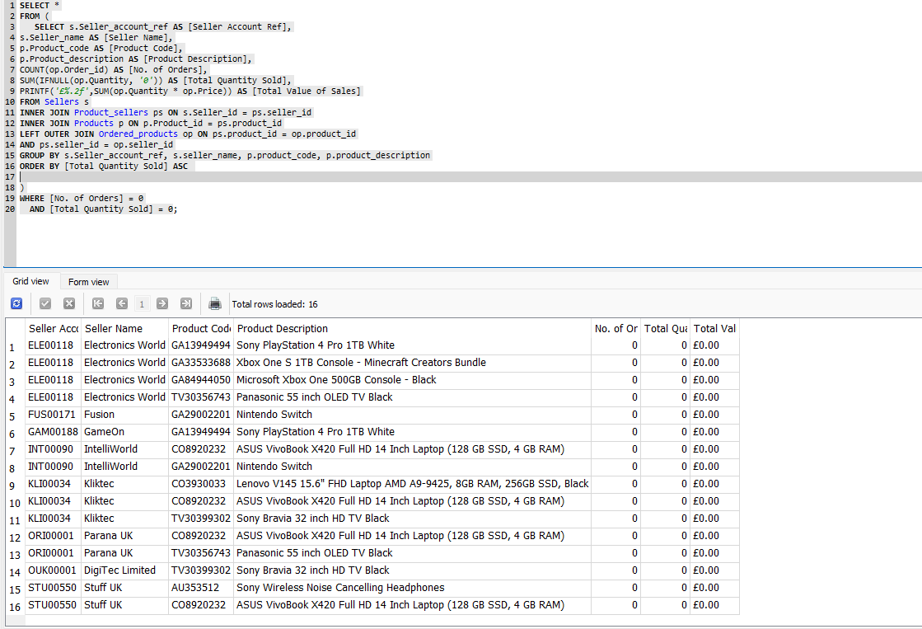

d) QUESTION:

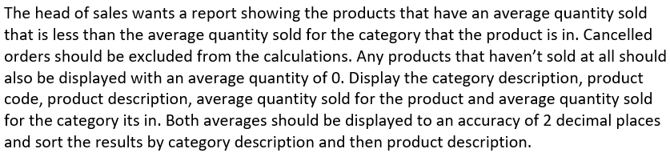

SQL CODE:

WITH Cat_avg AS (

SELECT p.category_id, AVG(op.quantity) AS Avg_cat_qty

FROM products p

INNER JOIN ordered_products op ON p.product_id = op.product_id

INNER JOIN shopper_orders so ON op.order_id = so.order_id

WHERE so.order_status != 'Cancelled'

GROUP BY p.category_id)

SELECT c.category_description AS [Category Description],

p.product_code AS [Product Code],

p.product_description AS [Product Description],

PRINTF("%.2f", IFNULL(op.quantity, '0')) AS [Avg Qty Sold],

PRINTF("%.2f", IFNULL(ca.Avg_cat_qty, '0')) AS [Avg Qty Sold for Category]

FROM products p

INNER JOIN categories c ON p.category_id = c.category_id

LEFT OUTER JOIN ordered_products op ON p.product_id = op.product_id

LEFT OUTER JOIN Cat_avg ca ON p.category_id = ca.category_id

WHERE op.quantity < ca.Avg_cat_qty

OR op.quantity ISNULL

ORDER BY c.category_description, p.product_description

EXPLANATION:
Line 1-7 show the use of a common table expression (cte) which allows for the creation of a temporary results set to be created and referenced within the SELECT statement. Line 2 and lines 8-12 uses a select statement to select the category id, quantity, category description, product code, product description and average category quantity, along with the use of aliases to make the columns easier to identify and read. Line 2 uses an average function on the quantity to find the average value in the column. Lines 11 and 12 use a printf function with a ifnull keyword nested inside it to format the quantity and average category quantity with pound signs and to 2 decimal places and change any null values to 0. Lines 3 and 13 use a FROM statement to show the data is being taken from the products table. Lines 4,5 and 14-16 use joins to join the tables together using matching rows. 15 and 16 use outer joins to return all results from the left tables and any matching results in the right tables. Line 6 and 17 use the from statement to condition the results to show results that aren’t cancelled in the order status and where the quantity is less than the average category quantity. Line 18 uses an or condition to show other results where the quantity is null. Line 19 uses a order by statement to filter the results by category description and then product description.

SCREENSHOT:

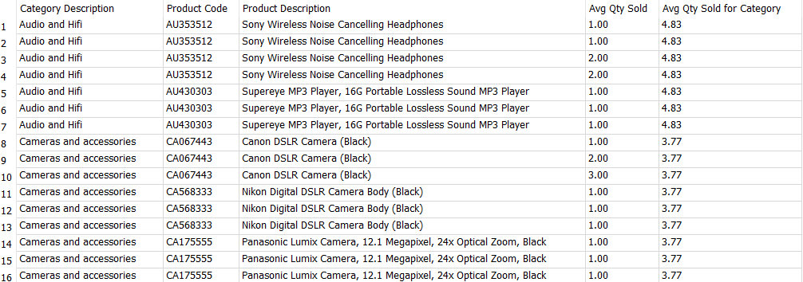

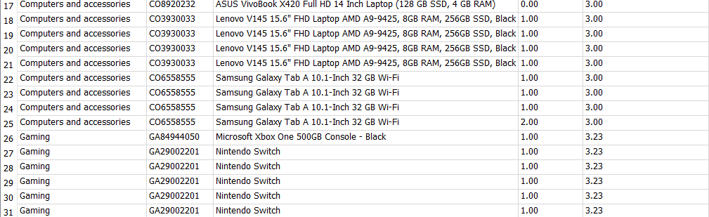

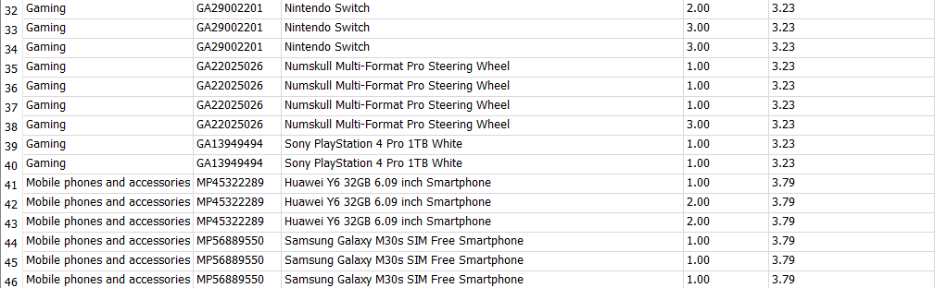

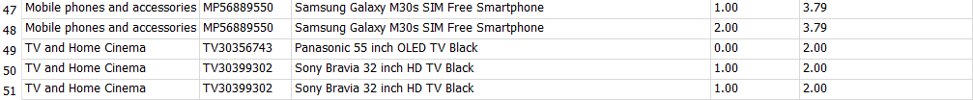

TESTING:
As I believe this query is incorrect but cannot figure out how to fix it, I feel I cannot check it to ensure its correct as I don’t believe it is

